**EFFECT OF FOREIGN DIRECT INVESTMENT ON ECONOMIC GEOETH IN KEYA**

# **ABSTRACT**

**Over the last 5 years, Kenya has been experiencing a rise in economic growth while FDI inflows steadily decrease annually. Primary objective of this study is to determine the impact of Foreign Direct Investment(FDI) on Kenya’s economy(GDP). Previous empirical studies have yielded various conclusions regarding the association between these two variables. This analysis aimed to add to existing literature and provide a more recent view for comparison. Variables selected included GDP, FDI, Manufacturing, Infrastructure and Inflation as the control variable. Secondary data for analysis was sourced from the World Bank within the period (1993-2022). The study adopted a quantitative research design using STATA software version 15.0, SPSS and Microsoft Excel which facilitated data analysis through descriptive statistics and multiple regression analysis for report creation from our findings. The multiple regression revealed that 98% ofthe variation in Kenya’s GDP can be explained by our model. According to the coefficients of the independent variables we found, FDI had a negative but insignificant impact on GDP. Inflation rate also had a negative impact, while manufacturing and infrastructure had positive impact on economic growth. Infrastructure was the only variable to have a significant impact on economic growth, highlighting the need for infrastructure development. The observed negative impact of FDI on economic growth is statistically insignificant (p= 0.181>0.05), hence the observed impact remains inconclusive. Our analysis informs policy makers to take part in bilateral and multilateral trade agreements to open up the economy to foreign investments and implement anti-corruption policies to create an investor friendly environment and protect local firms. The government should also focus on critical infrastructure specifically transport networks, power supply and digital connectivity.**

**ABSTRACT** 1

**INTRODUCTION** 2

Backgroundofstudy 2

Objectives 3

**METHODOLOGY** 3

Research Design 3

Data Source 3

Definition of Variables 3

Econometric Model 4

**DATA** **ANALYSIS** **AND** **PROCESSING** 5

Introduction 5

Regression 5

Findings 5

Conclusion 7

Recommendations 7

# **INTRODUCTION**

## **Background of study**

**Foreign Direct Investment(FDI) is recognized as a significant contributor to economic growth. This can be achieved because FDI avails capital, technology and knowledge transfers, job creation and creating trade networks to the benefit of industries. However, it is also important to acknowledge the negative externalities that can occur, such as replacement of local firms and exploitation of local resources. Nevertheless, with well-structured laws and policies, the negative effects can be mitigated. To attract FDI, the government needs to create a more attractive business environment and improve infrastructure.**

## **Objectives**

**This study aims to determine the significance of FDI on economic growth in Kenya.**

**Determine impact of infrastructure on economic growth.**

# **METHODOLOGY**

## **Research Design**

**The study utilized Quantitative research design since our variable were numerical. Ordinary Least Squares method was adopted to create a regression model.**

## **Data Source**

**Secondary time series data was collected from the World Bank, within the period (1993-2022)**

## **Definition of Variables**

|  |  |  |  |  |
| --- | --- | --- | --- | --- |
| **Variable** | **Definition** | **Measurement** | **Data Source** | **Expected Effect on GDP** |
| Economic growth | Increase I real GDP from one period to another. | Actual GDP value in Billion USD. | World Bank |  |
| Foreign Direct Investment | Cross border transaction from one country to another’s business entity. | Actual FDI inflows value in Billion USD. | World Bank | Positive |
| Infrastructure | Basic physical systems that add in production process. | Population % with access to electricity. | World Bank | Positive |
| Manufacturing | Production of goods and services. | Manufacturing output in Billion USD. | World Bank | Positive |
| Inflation | Change in prices over time. | Annual percentage rate. | World Bank | Positive |

## **Econometric Model**

**GDP = f(FDI, MANF, INFR, INFL)**

**Y = Β0 + Β1X1 + Β2X2 + Β3X3 + Β4X4 + έ**

**Where**

**Y = Economic Growth**

**X1 = FDI**

**X2 = Manufacturing**

**X3 = Infrastructure**

**X4 = Inflation**

**Έ = Stochastic error term**

# **DATA** **ANALYSIS** **AND** **PROCESSING**

## Introduction

**STATA software version 15 was used for data analysis specifically performing regression. Microsoft Excel was used for loading, cleaning and organizing the data .**

## **Regression**

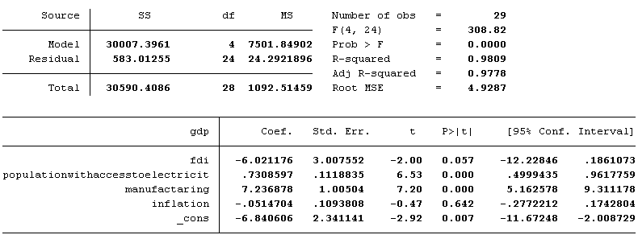

## **Visuals**

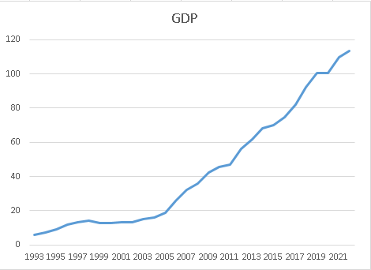

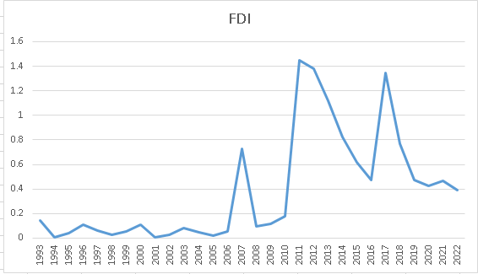

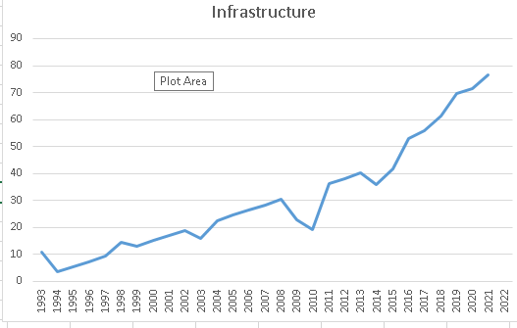

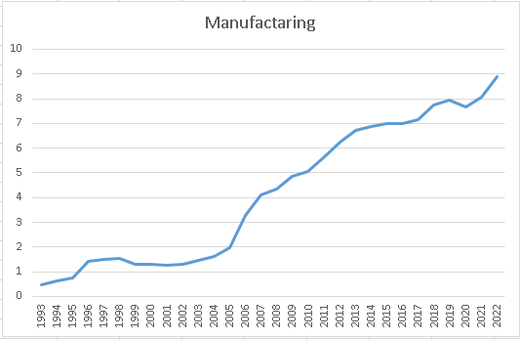

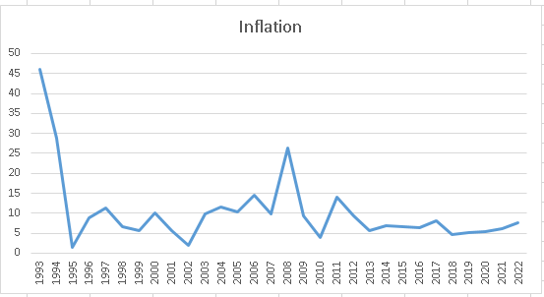

## **Findings**

**The coefficient of determination, or adjusted R-squared, tells us how much of the variance in the dependent variable can be explained by the independent variables.**

**Based on the data presented in Table , the R squared value was 0.9809. This suggests that foreign direct investment (FDI), inflation, Manufacturing and Infrastructure accounted for 98.09% of the variation in Kenya's GDP. The table also shows that the prob > F = 0.000 value is less than 0.05, indicating that the variables jointly explain the variation in the GDP value and are significant at the 5% level of significance.**

**The regression equation becomes**

**GDP = -6.021176FDI + 7.236878MANF + 0.8101061INFR -0.514704INFL - 6.840606**

**The regression coefficient for FDI was -6.021176 . This implies that all other variables held constant, increasing FDI by 1 unit causes GDP to decrease by 6.021176FDI Bn USD. At 5% level of significance, FDI is not statistically significant in predicting GDP, (p=0.057> 0.05).**

**The regression coefficient for inflation was -0.514704. This means that holding all other factors constant, one percentage point increase in inflation rate causes GDP to decrease by -0.514704 Bn USD. Independently, inflation rate was not statistically significant in predicting the value of GDP at 5% level of significance, (p=0.632> 0.`05).**

**Manufacturing was statistically significant in predicting GDP at 5% level of significance, (p= 0.00 < 0.05). Its regression coefficient of 7.236878 implies that increasing manufacturing output by 1 unit leads to an increase in GDP by 7.236878 Bn USD holding all other variables constant.**

**Infrastructure had a coefficient of 0. 8101061. Meaning that holding all other factors constant, a 1 unit increase in infrastructure corresponds to a 0 .8101061 Bn USD increase in GDP. Infrastructure was statistically significant in predicting GDP at 5% level of significance, (p=0.000 < 0.05).**

## **Conclusion**

**From the recession results, the negative impact FDI has on economic growth is statistically insignificant. Therefore, we cannot ascertain that FDI negatively affects the economy.**

**Manufacturing and Infrastructure were found to have positive and significant impact while infrastructure was negative as expected.**

**Only Manufacturing and Infrastructure had statistically significant coefficients.**

## **Recommendations**

**More in depth analysis should be carried out in future. This could be done through increasing the sample size to include more years and other factors influencing economic growth. Moreover, addition of external factors such as global economic trends and financial markets would shed more light on FDI inflows. Further analysis gives more insight and evaluates validity of our research.**

**The government should take part in multilateral and bilateral trade agreements to open the economy to more foreign investors, which will have a direct and positive impact on the economy as well as providing a market for the manufacturing sector.**

**There is need for more investment into infrastructure to improve quality and coverage. This can be accomplished by focusing on critical areas specifically transport networks, power supply and digital connectivity.**

**Sector specific measures should be set to maximize their individual contributions on economic growth. This can be through setting better policies and regulation, encouraging innovation and fostering value addition mechanisms in each sector.**

**Finally, measures need to be set to regularly evaluate the impact of policies and investments on economic growth. This can be accomplished through data driven analysis to inform policymakers on the best strategy to move forward.**